- Home Page
  - Professional headshot/picture of yourself
    - 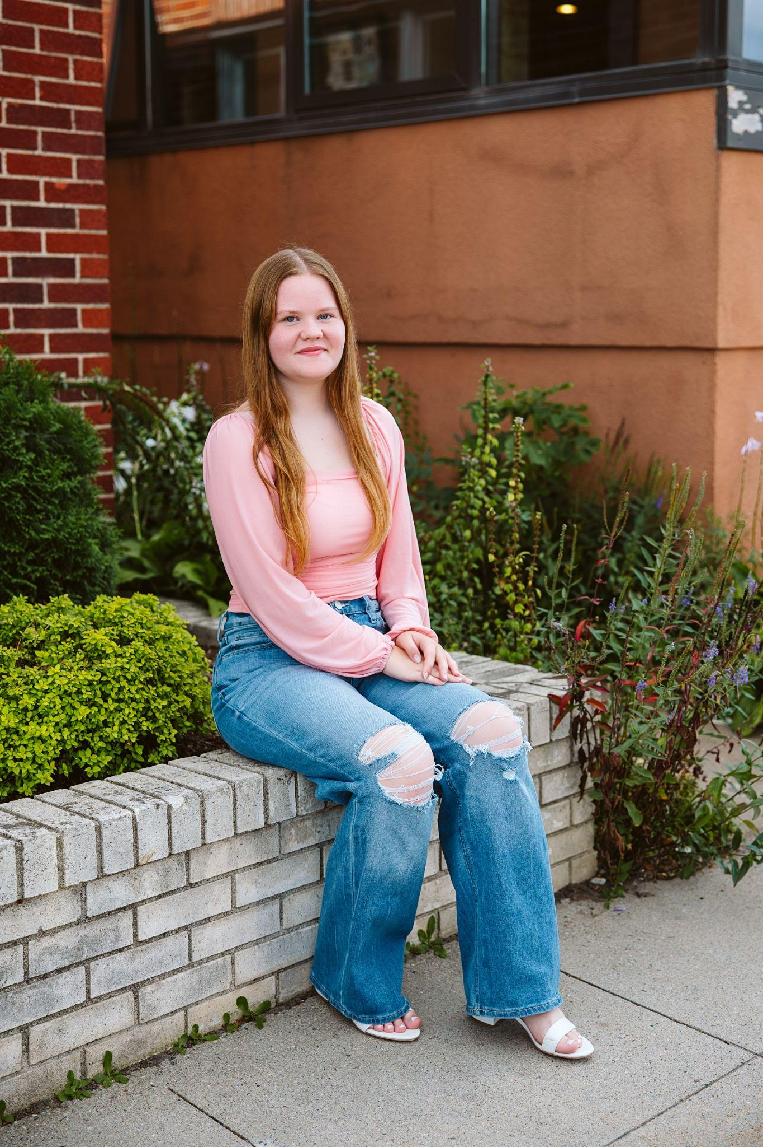
  - Two hobby summaries with accompanying pictures
    - FFA
      - FFA has been a huge part of my life, shaping who I am today. From competing in forestry contests to serving as a regional officer, I’ve learned leadership, teamwork, and confidence. These experiences gave me opportunities to grow and connect with amazing people who share my passion for agriculture and natural resources.
      - 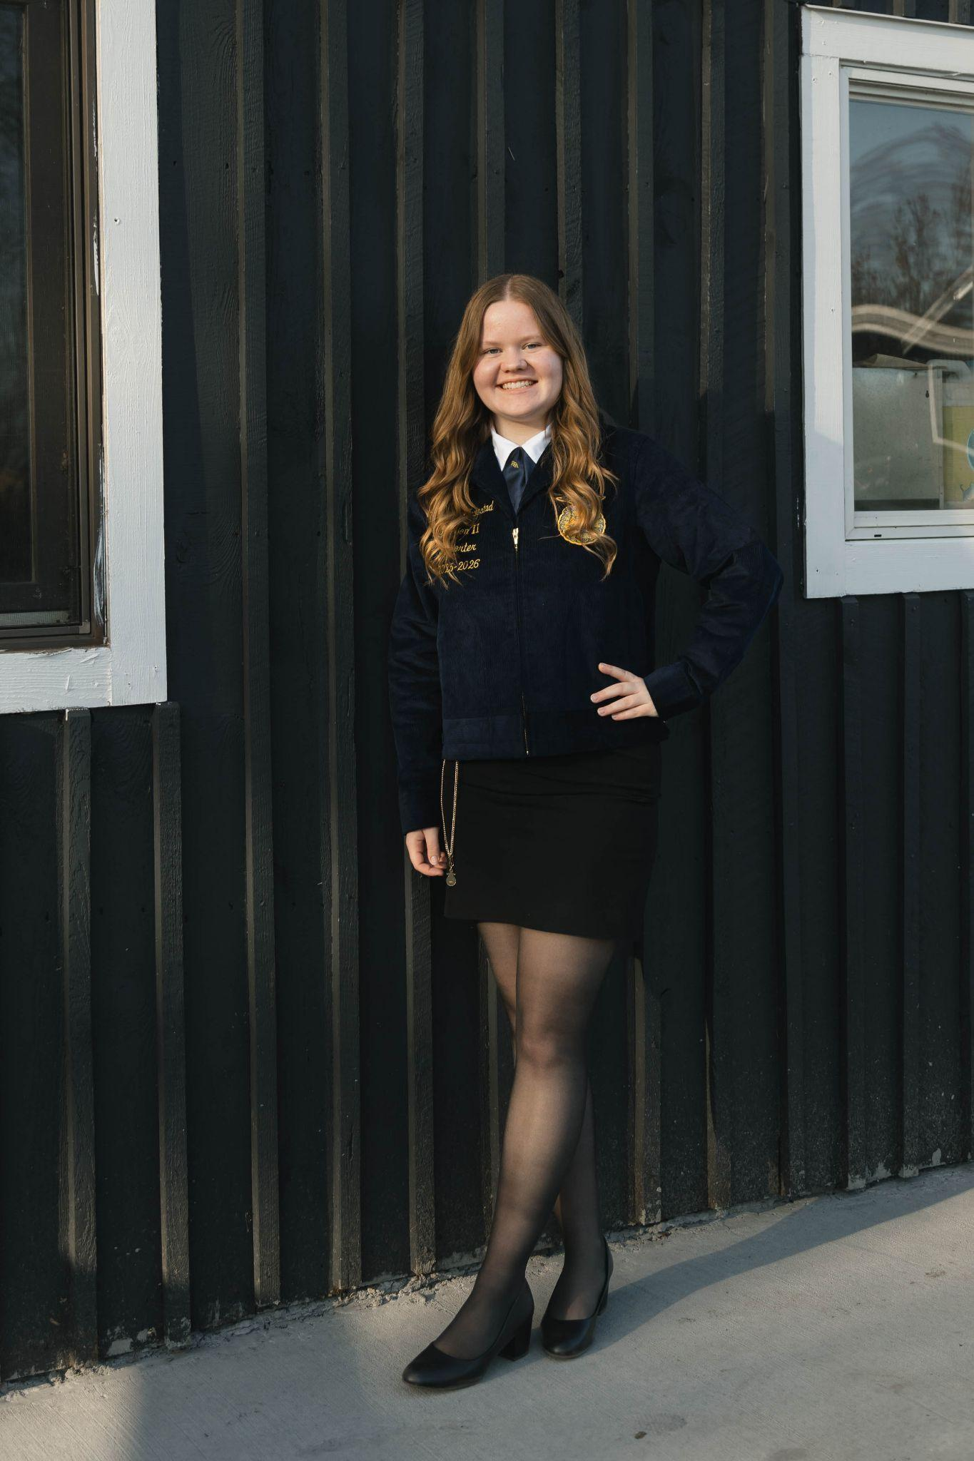
    - Reading
      - Reading has always been a fun hobby of mine, ever since I was working hard to get AR points back in elementary school. I love reading different fiction books, and can read for hours. Once I get started on a book, I will sit there until the book is finished. I still list reading as one of my top hobbies, just don’t look at how many books I’ve read so far this year. I have the goal of reading 25 books this year and so far I’ve read 4. It’s okay though, I still have the rest of the year.
      - 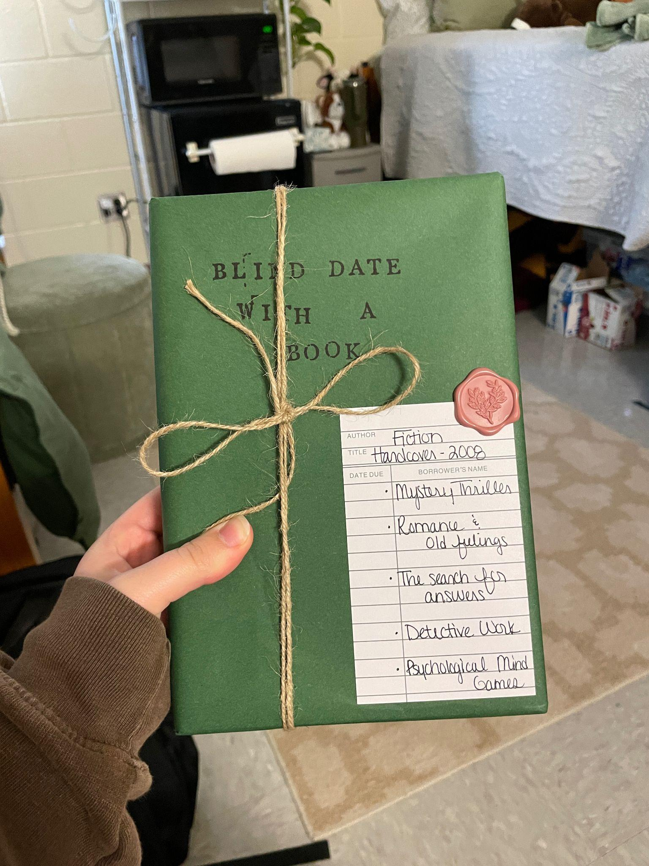
  - Short welcome video for visitors (introduce yourself)
    - Hi! My name is Harmony Trygstad. I’m a student at the University of Minnesota Duluth, majoring in Consumer Insights and Analytics. This site is a snapshot of who I am; my background, my passions, and the journey I’m on in college. Thanks for stopping by!
  - Professional introduction and overview
    - I’m pursuing my degree in Consumer Insights and Analytics at UMD because I’m fascinated by how people think, make decisions, and connect with products, brands, and stories. My long-term goal is to combine data, creativity, and human understanding to help organizations make better decisions.
- Hobbies Page
  - Detailed descriptions of your hobbies and favorite activities
    - FFA gave me some of my most rewarding high school experiences. I competed at a high level in forestry—earning first place in the state—and served as a regional officer, where I had the chance to help guide younger members and represent my peers. FFA wasn’t just about contests; it was about building leadership skills, learning responsibility, and working toward goals with a team…
    - Reading is one of my favorite hobbies because it balances out the busyness of everyday life. Books give me both relaxation and inspiration, whether I’m getting lost in a story, learning something new, or finding a character that feels a little bit like me. It’s also something I can share with others—recommending a great book or talking about a new favorite author…
    - I love to hang out with friends. Back home we would go to trivia at Zorbaz most Thursdays which was fun, even if we never actually won. We would also go to Walmart and peruse, since that was one of the only things to do in town. Now that I am in Duluth I have done so many fun activities with the people I have met here, getting to see so much of the city, both in nature and inside buildings.
  - Minimum of three pictures showcasing your interests
    - 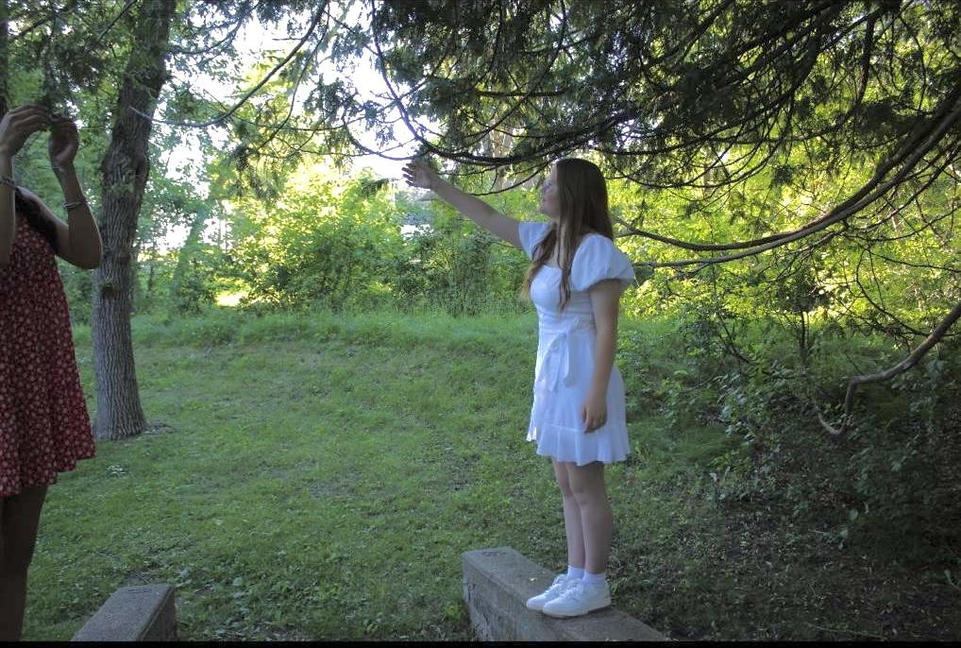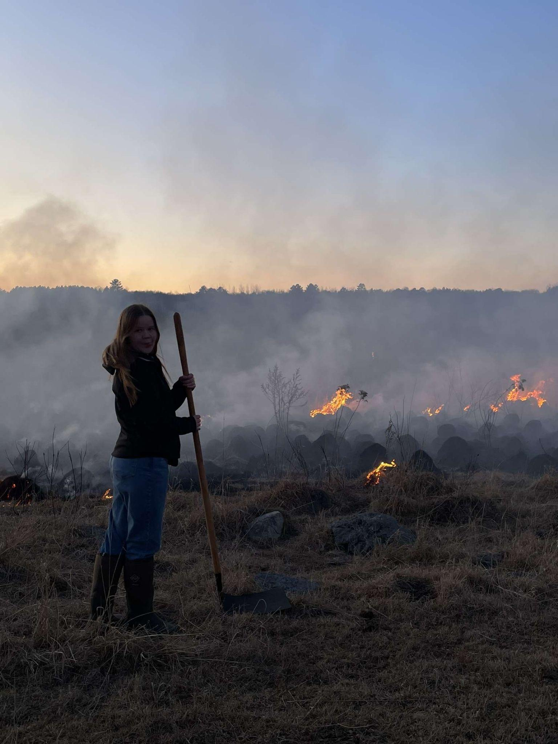
  - Personal stories and experiences related to your hobbies
    - Talk about going to national convention
    - Talk about the prescribed burn
    - Talk about the ididaread from third grade?
    - The Fargo book store?
  - Why these activities are important to you
    - FFA taught me leadership, discipline, and the value of community. Reading gives me creativity, empathy, and perspective. Together, these hobbies represent balance: achieving goals while also remembering to slow down and enjoy life. I love my friends and spending time with them makes me very happy.
- Discover Page (UMD & Duluth)
  - Why you chose University of Minnesota Duluth
    - I chose the University of Minnesota Duluth because it felt like the right fit both academically and personally. When I was exploring majors, I discovered Consumer Insights and Analytics in UMD’s catalog, and it immediately clicked with me. It was a unique program that aligned perfectly with my interests. UMD was also closer to home than Madison, making it both exciting and practical. And it's closer than Madison.
  - What you like about Duluth and the surrounding area
    - Duluth has surprised me with how much there is to do. Every week I’ve found something new to explore—festivals, beaches, trails, unique shops, and local restaurants. Coming from a smaller town, I appreciate having more options while still being surrounded by nature. The trees, the lake, and the changing seasons make this city feel special.
  - 30-second UMD marketing video (Group work - entire team can use same video)
  - Personal experiences and campus highlights
    - So far I’ve joined a variety of clubs:
      - Women in psychological sciences
      - Analytics club
      - Coffee Club
      - Asl club
      - The navigators
    - I also enjoy the fun housing activities like Hotdogs on Griggs beach and Nostalgia Night. One of my favorite things about UMD is how the campus is connected indoors—you can choose to stay cozy or go outside depending on your mood.
- Resume Page
  - Web-formatted version of your professional resume
    - Education
      - Park Rapids High School - High School Diploma 2025
      - University of Minnesota Duluth — B.B.A. in Consumer Insights & Analytics, Expected Graduation: 2029
    - Experience
      - FFA Region Officer — Led events, coordinated with schools, represented students in my region.
      - Forestry Contest Competitor — Placed first in state competition, demonstrating discipline, teamwork, and applied technical knowledge.
    - Skills
      - Leadership & teamwork
      - Public speaking & presentations
      - Communication & writing
    - Achievements
      - First in state forestry competition
      - Regional FFA Officer
      - Computer Applications Class - Basic proficiency in Microsoft products.
- Career Interests Section
  - Two companies you’re interested in working for
    - Leede has stood out to me because they do both qualitative and quantitative work, including focus groups, ethnography, and online panels. I like companies that don’t just collect data but really try to understand the context and story behind it. The fact that they’re well‐established in both Minnesota and Wisconsin makes them appealing, since I’d want to stay in the Midwest region.
      - Not only that but they have entry level positions open.
    - Several top companies will be attending the upcoming local job fair, offering exciting opportunities for recent graduates in consumer insights, analytics, and market research. Companies like 3M, ALLETE Inc., Brown & Brown Inc., Fastenal Company, Jack Link’s Protein Snacks, North Shore Bank, and SPS Commerce are actively hiring for roles such as Market Research Analyst, Consumer Insights Analyst, Data Analyst, and Business Insights Analyst. This is a great chance to connect with employers in the Midwest, learn about their entry-level openings, and explore potential career paths in market research and analytics.
  - Complete contact information for each company
    - 5353 Gamble Drive, Suite 150
St. Louis Park, MN 55416
    - 844-JOBS-FNL
  - How your skills and interests align with their needs
    - I am interested in Consumer Insights and Analytics, specifically the Market Research aspect and I think these look like good employers of this field.
- Interactive Game Page
  - Interactive page featuring a web-based game
  - Team project - entire team creates one game together
    - Game where objects are falling and then you try to catch them. Perhaps for our personal website it can be with things we’ve mentioned throughout our page while for the business it can be coffee things.
  - Game should be engaging and demonstrate JavaScript skills

- Technical requirements
  - HTML5 semantic structure for all pages
  - CSS styling with consistent design theme
  - Responsive design for mobile and desktop
  - Navigation menu linking all pages

- Professional color scheme and typography
  - Ideas:
      - #f0ead8, #8e9e84, #bdc5a5, #8b8e76, #69604e, #2d3021
      - #7c8e76, #ffffff, #4b3830
      - #ebe6e6, #b2aea9, #9da38c, #5d6e56, #b49e6f
      - #eae7e2, #d0c2b5, #8e9e84, #7d6f62, #37473d, #222222
- Optimized images and media files
- Clean-browser compatibility

Basic Timeline:
- October 7th:
  - Goal: Done By October 2nd
  - Homepage Basics Done
    - General Content: September 30th
    - General Style: October 1st
  - One Other Page Fairly Good Progress (Hobbies or Discover)
    - General Content: October 2nd
- October 14th:
  - Goal: Done By October 9th
  - Hobbies Page Basically Done
    - General Content: October 5th
    - Final Images and Stuff: October 6th
  - Discover Page (UMD/Duluth Content) Basically Done
    - General Content: October 7th
    - Final Images and Stuff: October 8th
  - Know What Two Companies For Career Interests Page And About Them
    - Know All the Stuff: October 9th
- October 21st:
  - Goal: Done By October 16th
  - Homepage Final Version
    - All the Final Links: October 10th
    - All the Final Design Elements: October 11th
  - Resume Page w/Downloadable Version Done
    - Final Achievements and Stuff Added: October 12th
    - Final Version downloadable: October 12th
  - Career Interests Page Done
    - Final Company Descriptions: October 13th
    - Formatted Well: October 14th
  - Completed WebPage.
    - All the Pages Look GREAT: October 16th

Harmony Trygstad
Duluth, MN | 218-255-1805 | harmonytrygstad@gmail.com

Objective
Motivated pre-business student at the University of Minnesota Duluth, pursuing a Bachelor’s in Consumer Insights and Analytics (expected 2029). Seeking entry-level opportunities in market research and consumer insights where I can leverage my analytical skills, leadership experience, and passion for understanding consumer behavior to contribute to data-driven business decisions.

Education
University of Minnesota Duluth – Duluth, MN
Bachelor of Business Administration, Consumer Insights & Analytics (Expected 2029)
- Relevant coursework: IT in Business
Park Rapids High School – Park Rapids, MN
High School Diploma, Salutatorian, GPA: 3.99
- Relevant coursework: Computer Applications, Webpage Development

Experience
Cabin Cleaner – Loon’s Nest Resort, Park Rapids, MN | Summer 2023
- Maintained cleanliness and organization of guest cabins, ensuring a welcoming environment for visitors.
- Developed attention to detail and time management skills.
Attraction Attendant – Evergreen Fun Park, Park Rapids, MN | Summer 2024
- Assisted guests on rides and attractions while maintaining safety standards.
- Provided excellent customer service and learned to adapt quickly to changing environments.
Mini Golf Attendant – Birdie’s Mini Golf, Park Rapids, MN | Summer 2025
- Managed day-to-day operations and interacted with customers, strengthening interpersonal and problem-solving skills.

Leadership & Activities
FFA (Future Farmers of America) – Active Member & Regional Officer
- Led events, mentored peers, and represented the region in competitions.
- Developed leadership, public speaking, teamwork, and organizational skills.
UMD Analytics Club - Active Member Going to Regular Meetings
UMD ASL Club - Active Member Going to Regular Meetings

Skills
- Microsoft 365 Suite (Word, Excel, PowerPoint, Outlook)
- Leadership & teamwork
- Webpage development and IT in business basic knowledge
- Strong communication and interpersonal skills

Honors & Achievements
- Salutatorian, Park Rapids High School
- First place, State FFA Forestry Contest
- Regional Officer, FFA

